**SMART FARMING – AN IOT ENABLED SMART FARMING APPLICATION**

**SPRINT -4**

**TEAMID: PNT2022TMID03145**

**PROJECT DEVELOPMENT PHASE**

**Receiving commands from IBM cloud**

import time

import sys

import ibmiotf.application import ibmiotf.device import random

organization = "157uf3" deviceType = "abcd" deviceId = "7654321" authMethod = "token" authToken = "87654321"

def myCommandCallback(cmd):

print("Command received: %s" % cmd.data['command']) status=cmd.data['command'] if status=="motoron": print ("motor is on") elif status == "motoroff": print ("motor is off") else :

print ("please send proper command")

try:

except Exception as e:

print("Caught exception connecting device: %s" % str(e)) sys.exit()

# Connect and send a datapoint "hello" with value "world" into the cloud as an event of type "greeting" 10 times deviceCli.connect()

while True:

#Get Sensor Data from DHT11 temp=random.randint(90,110) Humid=random.randint(60,100) Mois=random. Randint(20,120)

data = { 'temp' : temp, 'Humid': Humid ,

‘Mois’: Mois}

#print data def myOnPublishCallback():

print ("Published Temperature = %s C" % temp, "Humidity = %s %%" % Humid, “Moisture =%s deg c” % Mois “to IBM Watson")

success = deviceCli.publishEvent("IoTSensor", "json", data, qos=0, on_publish=myOnPublishCallback) if not success:

print("Not connected to IoTF") time.sleep(10)

deviceCli.commandCallback = myCommandCallback # Disconnect the device and application from the cloud deviceCli.disconnect()

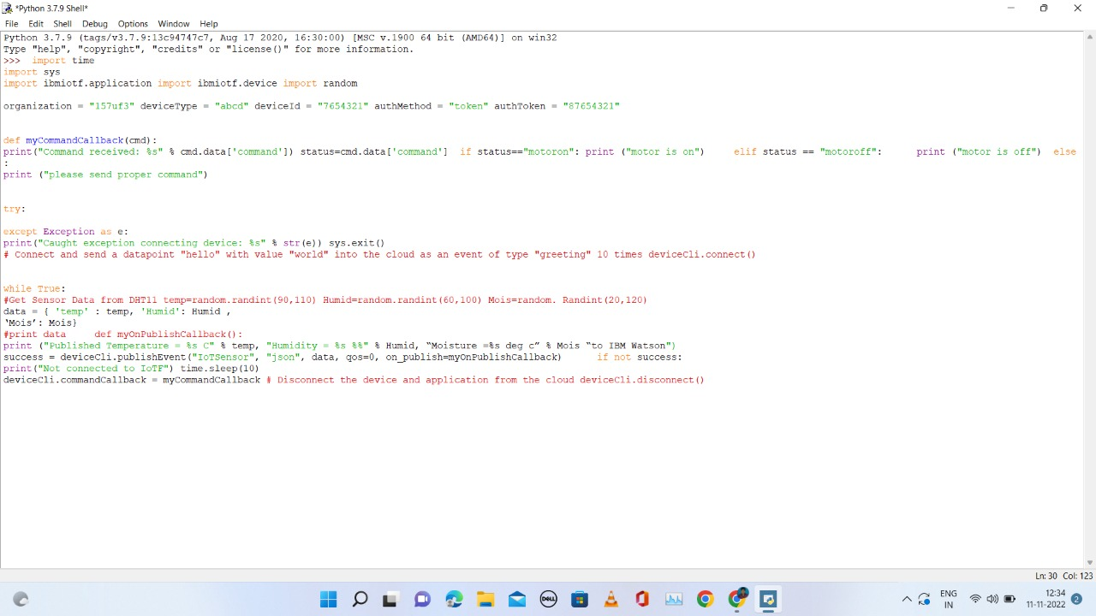

Python 3.7.0 (v3.7.0:lbf9cc5093, Jun 27 2018, 04:59:51) [MSC v.1914 64 bit (AMD6 ’ ’

4)] on win32

Type ’copyright’, "credits" or ’license() " for more information.

==--==== RESTART: C:\Users\ELCOT\Downloads\ibmiotpublishsubscribe.py ========

2022-11-07 20:01:24,074 ibmiotf.device.Client INFO Connected successfu -

lly: d:157uf3:abcd:7634321

Published Moisture = 90 deg C Temperature = 96 C Humidity = 76 % to IBM Uetxon Published Moisture - 103 deg C Tsmperaturs - 110 C Humidity - 68 % té IBM Uatmon Published Moisture = 45 deg C Temperature - 99 C Humidity - 100 % to IBM Watson Command received: motoron

motor is on

Published Moisture = 77 deg C Temperators = 91 C Humidity = 85 % to IBM Watson Published Moisture = 73 deg C Temperature - 94 C Humidity = 86 % to IBM Watson Command received: motoroff

aotor is off

Published Moisture = 101 deg C Temperature = 104 C Humidity = 87 % to IBM Uateon

1. Flow Chart

INTERNET

GATEWAY

CODING(PYTHON)

simulator

IBM CLOUD PLATFORM

NODE RED

END USER

(FARMER)

API

INPUT FROM SENSOR

1. **Observations & Results**

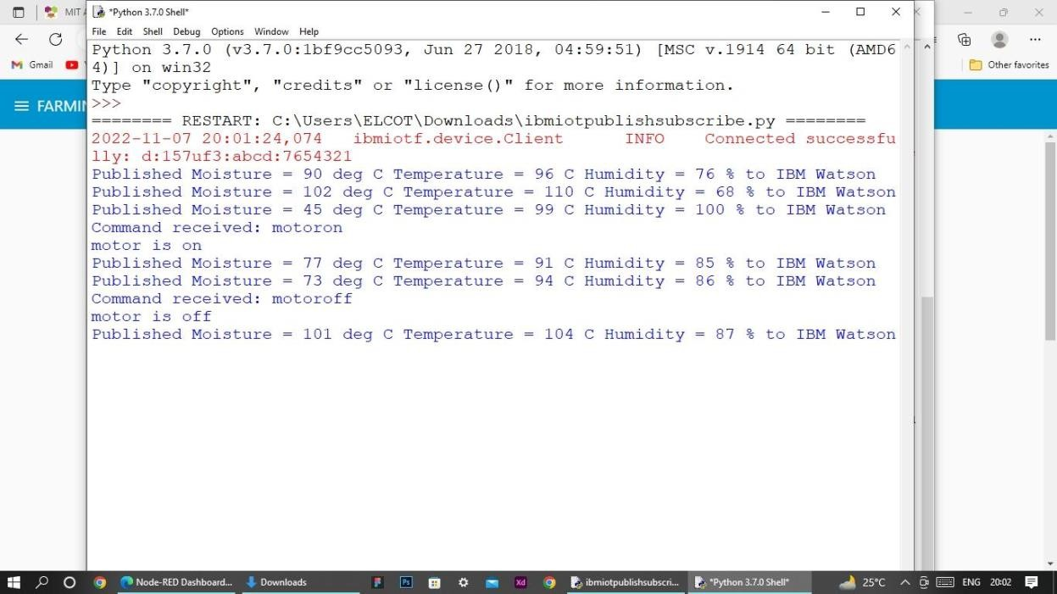

 

Farmin5 M easure Data

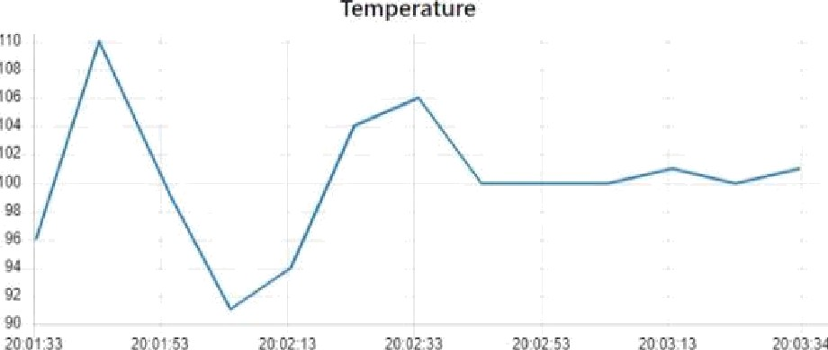

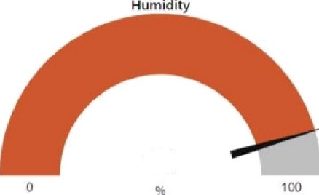

91

Moisture

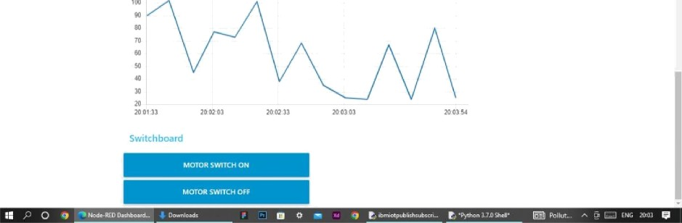

**8. Advantages:**

* Farms can be monitored and controlled remotely.
* Increase in convenience to farmers.
* Less labor cost.
* Better standards of living. **Disadvantages**:
* Lack of internet/connectivity issues.
* Added cost of internet and internet gateway infrastructure.
* Farmers wanted to adapt the use of Mobile App. 9.**Conclusion**

Thus the objective of the project to implement an IoT system in order to help farmers to control and monitor their farms has been implemented successfully.

**10.Bibliography**

IBM cloud reference: https://cloud.ibm.com/

IoT simulator : https://watson-iot-sensor-simulator.mybluemix.net/ OpenWeather : https://openweathermap.org/